HomeWork 3 – Big Data

Hive Services started

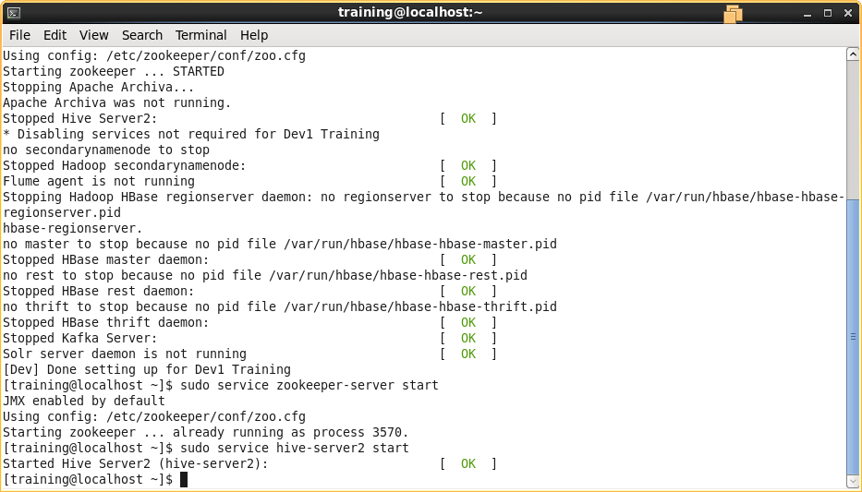

The webpage was successfully loaded into HDFS.

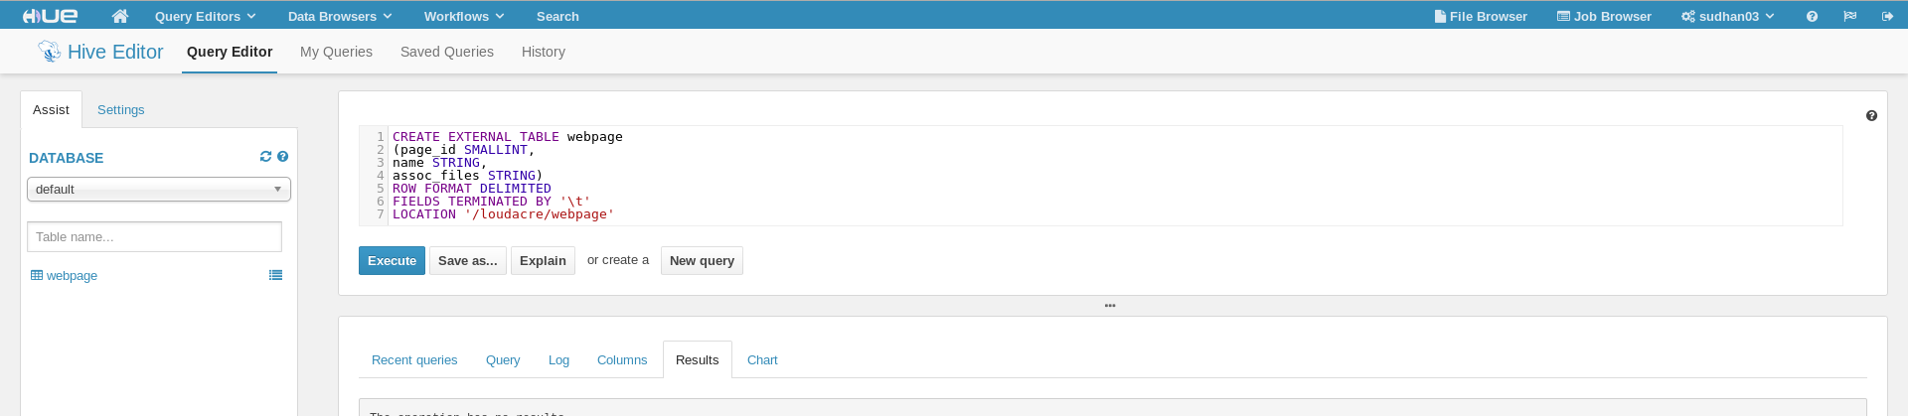

Sampling of the Data – Preview Plane

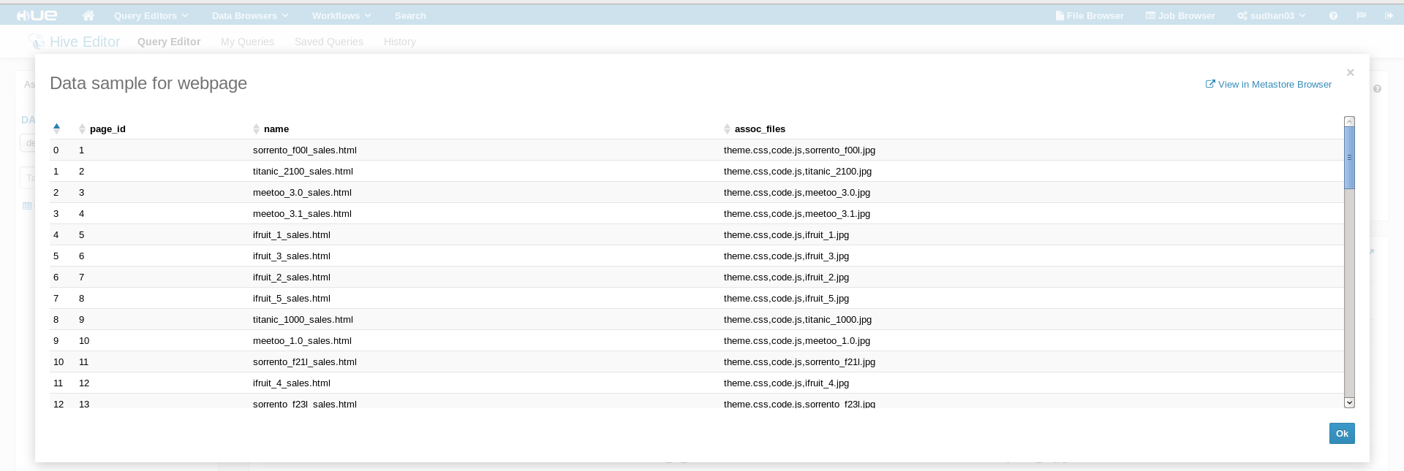

**Use Sqoop to Import Directly into Hive and Impala**

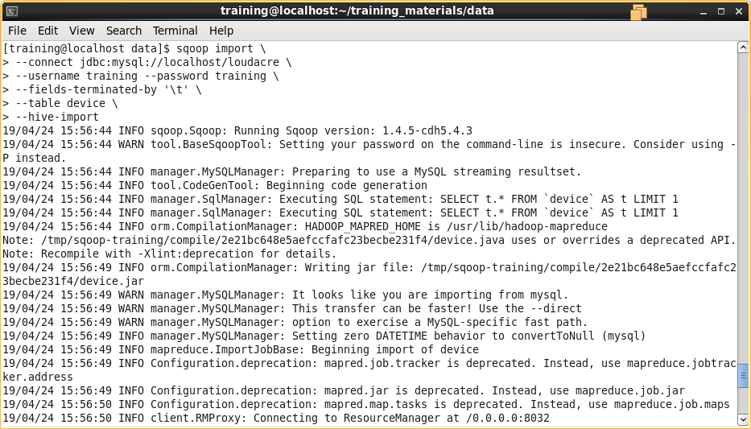

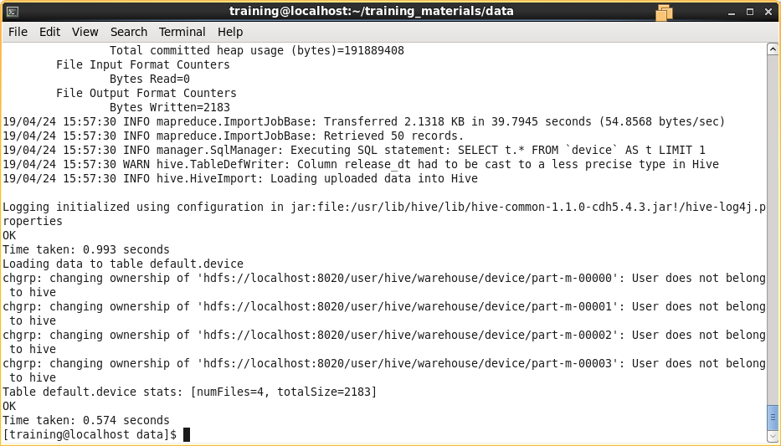

Top 10 rows of Device Table

